EXPERIMENT 7

Linear Regression

Aim:

To understand the importance of linear regression.

Algorithm:

1. Import the required libraries — numpy, pandas, sklearn, and pickle.

2. Load the salary dataset using pd.read_csv().

3. Separate the dataset into features (Years of Experience) and target (Salary) variables.

4. Split the data into training and testing sets using train_test_split().

5. Create a Linear Regression model and train it on the training data.

6. Evaluate the model using R² scores, and display the slope and intercept.

7. Save the trained model using the pickle module and reload it.

8. Predict the estimated salary for a given number of years of experience and display the result.

Program:

import numpy as np

import pandas as pd

from sklearn.model_selection import train_test_split

from sklearn.linear_model import LinearRegression

import pickle

df = pd.read_csv("C:\Salary_data.csv")

X = df.iloc[:, [0]].values

y = df.iloc[:, [1]].values

x_train, x_test, y_train, y_test = train_test_split(X, y, test_size=0.2)

model = LinearRegression()

model.fit(x_train, y_train)

print("Training Score (R²):", model.score(x_train, y_train))

print("Testing Score (R²):", model.score(x_test, y_test))

print("Coefficient (Slope):", model.coef_)

print("Intercept:", model.intercept_)

pickle.dump(model, open("SalaryPred.model", "wb"))

model = pickle.load(open("SalaryPred.model", "rb"))

yr_of_exp = 44.0

salary = model.predict(np.array([[yr_of_exp]]))

print("Estimated Salary for {} years of experience is {}"

.format(yr_of_exp, salary))

Output:

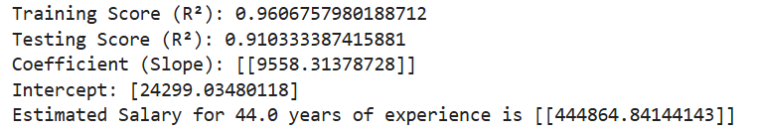

Result:

Hence a python program for linear regression is written and executed successfully.